
Smart Delivery Route System(Trackmile)
By
Tejas thakor

Executive Summary
The SmartDeliveryRoute backend is the core processing engine for the "TrackMile" logistics platform. My role was to architect a robust, scalable RESTful API system using Java Spring Boot and MongoDB. The backend facilitates real-time data flow between the React.js frontend and the database, managing critical operations such as user authentication, dynamic route planning, and high-frequency GPS telemetry ingestion. Additionally, the system supports a distinct "Admin vs. Driver" module architecture to streamline fleet management.

PROJECT OBJECTIVES
The primary objectives of the SmartDeliveryRoute backend were:
- To design a layered architecture that separates concerns between data access, business logic, and API control.
- To implement a NoSQL database (MongoDB) capable of handling flexible schemas for route plans and high-volume telemetry data.
- To expose secure and efficient RESTful APIs for frontend applications (web or mobile) to consume.
- To manage geospatial data (GeoPoint) effectively for accurate tracking and routing
- Spring Boot and MongoDB to handle complex geospatial data and high-frequency telemetry updates

Technical Stack
- Language: Java
- Framework: Spring Boot (providing Dependency Injection, MVC structure, and ease of configuration)
- Database: MongoDB (NoSQL database chosen for its performance with JSON-like documents and geospatial querying capabilities)
- Build Tool: Maven (implied by the .mvn folder and standard structure)
- Architecture Pattern: Controller-Service-Repository (Layered Architecture)

backend architecture and implementation
As the lead for the server-side architecture, I was responsible for designing and implementing the core backend infrastructure using Spring Boot. This role encompassed:
- RESTful API Engineering: Designed secure endpoints (GET, POST, PUT, DELETE) to manage critical resources like Driver, Order, and User, serving as the reliable bridge between the client-side application and the database.
- Robust Error Handling: Implemented defensive programming techniques to ensure consistent JSON response structures and prevent server crashes during invalid requests.
- Controller Implementation: Developed the AdminController and AuthController to route incoming web requests effectively, enforcing the separation of concerns within the MVC architecture.

sYSTEM aRCHITECTURE AND COMPONENT BREAKDOWN
The project follows a standard industry-grade Layered Architecture. Below is a detailed breakdown of the components I created, based on the project file structure.
- Architectural Pattern: I implemented a Layered Architecture (Controller-Service-Repository) to ensure separation of concerns.
- Controller Layer: Handles incoming HTTP requests (GET/POST) and maps them to business logic.
- Service Layer: Encapsulates core logic (e.g., validating driver status, processing location updates).
- Repository Layer: Utilizes Spring Data MongoDB for efficient data abstraction.
- Client-Server Interaction: The system uses a Polling Mechanism where the frontend polls the backend every 5 seconds for live location updates.

Database Design & Implementation
The database is built on MongoDB to handle flexible schemas and nested JSON objects required for location data.
Key Collections Designed:
- drivers: Stores static profile data and dynamic fields (currentLat, currentLng, status) for live tracking.
- orders: Manages the state machine of a delivery (Assigned → In Transit → Delivered).
- users: Handles role-based authentication (Admin/Driver)
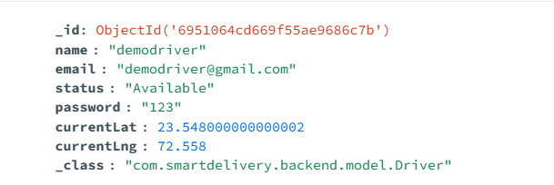

API Development & Live Tracking Logic
I developed a suite of RESTful endpoints to drive the application's features. The most critical component is the Live Tracking Algorithm.
The Real-Time Tracking Loop:
- Ingestion: The Driver App sends a POST request to /api/driver/update-location with new coordinates triggered by simulated checkpoints.
- Processing: The Backend Service updates the specific driver document in MongoDB instantly.
- Consumption: The Admin Dashboard calls /api/admin/driver-location (via a polling interval), retrieving the latest coordinates to render the blue route line on the map.
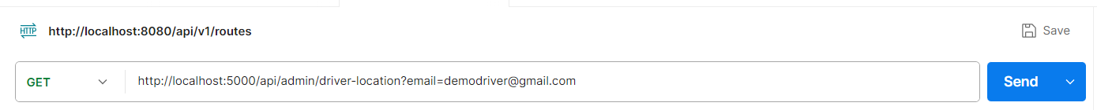
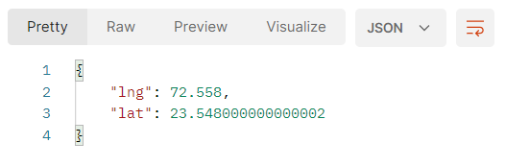

KEY FEATURES IMPLEMENTED

Key Features Implemented
  - Automated Order Management: Logic to create orders and assign them to specific drivers, preventing double-booking.
  - Role-Based Security: Backend logic to ensure Drivers cannot access Admin analytics.
  - Data filtering: Implementation of Java Streams to filter "Today's Deliveries" based on the LocalDate timestamp, ensuring accurate daily analytics.

cONCLUSION
The backend for SmartDeliveryRoute has been successfully architected to support a modern delivery tracking application. By leveraging the flexibility of MongoDB and the robustness of Spring Boot, we have created a system that is both scalable and maintainable. The separation of concerns through the Controller-Service-Repository pattern ensures that future features, such as route optimization algorithms or notification services, can be added with minimal friction.

